

**[PARALLEL AND DISTRIBUTED COMPUTING](https://horizon.ucp.edu.pk/student/course/gradebook/nyvEp16gQBZOvr0a5ow7)**

**Project Presentation**

**L1S23BSCS0257 Faheem Raza**

**L1S22BSCS0211 Ali Ahmad**

**L1S22BSCS0188 Abdullah Manzoor**

**L1S22BSCS0217 Eman Awan**

**L1S22BSCS0215 Hamza Amir**

**L1S22BSCS0215 Rana Hassan**

**Parallel and Distributed Computing Project**

Project Background (Dataset-Based) 5

Serial Implementation (Sequential Execution Method) 6

1. parse_line() 7
2. reset_query_defaults() 7
3. is_only_number() 7
4. parse_query() 7
5. matches_filter() 7
6. calculate_score() 8
7. sort_topk() 8
8. main() 8

Pthread Implementation (Shared-Memory Multithreading) 9

1. parse_line() 11
2. reset_query_defaults() 11
3. is_only_number() 11
4. parse_query() 11
5. matches_filter() 11
6. calculate_score() 12
7. sort_topk() 12
8. process_range() ✅ (THREAD FUNCTION) 12
9. pthread_mutex_lock() / pthread_mutex_unlock() ✅ (PRINT LOCK) 12
10. main() 13

Client–Server Implementation (UDP-Based Communication) 14

UDP CLIENT CODE 14

1. is_only_number() 14
2. Command Line Arguments Handling 14
3. Socket Creation 14
4. Server Address Setup 15
5. User Query Input 15
6. Sending Query to Server 15
7. Receiving Server Response 15
8. Closing Socket 15

UDP SERVER CODE 16

1. Global Dataset Arrays 16
2. Query Parameters 16
3. parse_line() 16
4. parse_query() 16
5. matches_filter() 16
6. calculate_score() 17
7. sort_topk() 17
8. process_query_and_format() 17
9. Dataset Loading (in main) 17
10. UDP Socket Creation & Binding 17
11. Receiving Client Queries 18
12. Sending Response to Client 18
13. Continuous Server Loop 18

OpenMP Implementation (Shared-Memory Parallelism with Directives) 19

1. is_only_number() 19
2. reset_query_defaults() 19
3. parse_line() 19
4. parse_query() 19
5. matches_filter() 20
6. calculate_score() 20
7. sort_topk() 20
8. main() (OpenMP part) 20

MPI Implementation (Distributed-Memory Message Passing) 21

. 21

is_only_number() 21

reset_query_defaults() 21

parse_line() 21

parse_query() 22

matches_filter() 22

calculate_score() 22

sort_topk() 22

bcast_dataset() 23

main() 23

Comparison of Execution Models 24

Advantages Table 24

Disadvantages Table 24

When to Use Which? 24

Time Comparison Table 25

# Project Background (Dataset-Based)

This project, *Wander-Hub-AI*, is developed as a **smart travel recommendation system** to demonstrate the practical application of **Parallel and Distributed Computing concepts** using a real-world dataset. The system uses a comprehensive Pakistan-based travel dataset stored in a text file (package_dataset_pakistan.txt), where each record represents a travel package containing attributes such as **package ID, destination name, province, category, duration (days), pricing details, user rating, number of reviews, and popularity score**. As the dataset size grows, sequential processing becomes inefficient; therefore, the project implements multiple execution models including **Serial, Pthreads, OpenMP, MPI, and Client–Server architecture** to efficiently filter, rank, and recommend the best travel packages based on user preferences. By processing the same dataset across different computational models, the project highlights how parallelism and distributed execution significantly reduce execution time while maintaining result accuracy, making it suitable for both academic demonstration and scalable real-world recommendation systems.

# Serial Implementation (Sequential Execution Method)

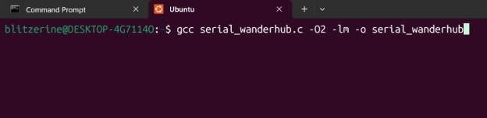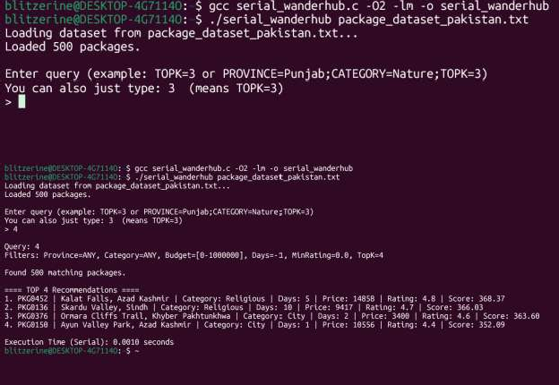

-O2 → Optimization Level 2

-lm → Link the Math Library

1. **parse_line()**



### What it does:

Reads **one row** from the dataset file and saves its data.

### In simple words:

* + It takes one line from the file
  + Splits it using **tab (\t)**
  + Stores values like package ID, place, province, price, rating, etc.
  + Skips the **header row**

👉 **Used for:** Loading dataset into memory.

1. **reset_query_defaults()**

### What it does:

Resets all search filters to default values.

### In simple words:

* + Clears province and category
  + Sets large budget range
  + Sets TOPK = 5
  + Removes day and rating filters

👉 **Used for:** Making sure old queries do not affect new ones.

1. **is_only_number()**

### What it does:

Checks if user input contains **only numbers**. **In simple words:**

* + If user types 3, it returns true
  + If user types TOPK=3, it returns false

👉 **Used for:** Treating input like 3 as **TOPK = 3**.

1. **parse_query()**

### What it does:

Reads the user’s query and sets filters.

### In simple words:

* + First resets all filters
  + If user types only a number → sets TOPK
  + Otherwise reads filters like:
    - Province
    - Category
    - Budget
    - Days
    - Rating
    - TopK

👉 **Used for:** Understanding what the user wants to search.

1. **matches_filter()**

### What it does:

Checks if a package matches the user query.

### In simple words:

* + Checks province match



* + Checks category match
  + Checks budget range
  + Checks number of days
  + Checks minimum rating

👉 **Returns:**

* + YES (1) → package is valid
  + NO (0) → package is rejected

1. **calculate_score()**

### What it does:

Gives a **score** to each package.

### In simple words:

* + Higher rating → higher score
  + More popularity → higher score
  + More reviews → higher score
  + Price close to budget → extra score
  + Days close to required → extra score

👉 **Used for:** Ranking packages.

1. **sort_topk()**

### What it does:

Sorts packages by score (highest first).

### In simple words:

* + Uses bubble sort
  + Best package comes at the top
  + Worst package goes down

👉 **Used for:** Showing best recommendations first.

1. **main()**

### What it does:

Controls the **whole program**. **In simple words:**

1. Opens dataset file
2. Reads and stores all packages
3. Takes user query
4. Filters packages
5. Calculates score
6. Sorts results
7. Prints top recommendations
8. Shows execution time

👉 **This is the brain of the program.**

# Pthread Implementation (Shared-Memory Multithreading)

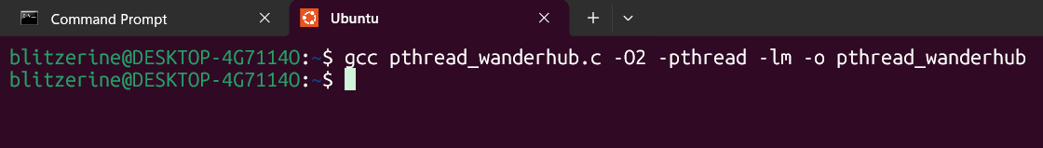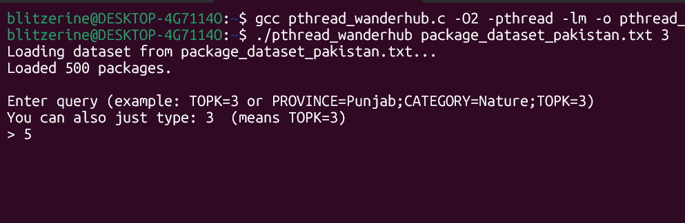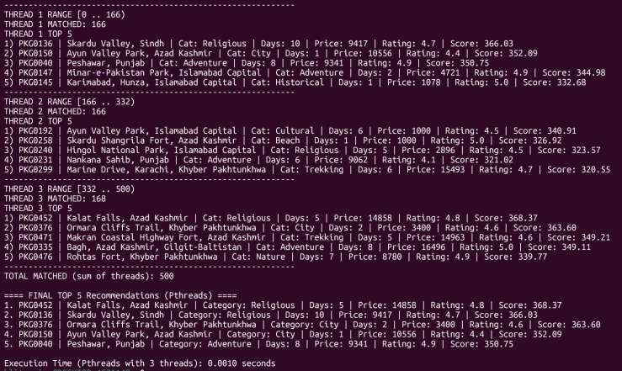

### Query for no of threads 3



1. **parse_line()**



### What it does:

Reads one row from the dataset file and saves its data.

### In simple words:

* + Takes one line from the file
  + Splits it using tab (\t)
  + Stores values like package ID, place, province, price, rating, etc.
  + Skips the header row

👉 **Used for:** Loading dataset into memory.

1. **reset_query_defaults()**

### What it does:

Resets all search filters to default values.

### In simple words:

* + Clears province and category
  + Sets large budget range
  + Sets TOPK = 5
  + Removes day and rating filters

👉 **Used for:** Making sure old queries do not affect new ones.

1. **is_only_number()**

### What it does:

Checks if user input contains only numbers.

### In simple words:

* + If user types 3, it returns true
  + If user types TOPK=3, it returns false

👉 **Used for:** Treating input like 3 as TOPK = 3.

1. **parse_query()**

### What it does:

Reads the user’s query and sets filters.

### In simple words:

* + First resets all filters
  + If user types only a number → sets TOPK
  + Otherwise reads filters like:
* Province
* Category
* Budget
* Days
* Rating
* TopK

👉 **Used for:** Understanding what the user wants to search.

1. **matches_filter()**

### What it does:



Checks if a package matches the user query.

### In simple words:

* + Checks province match
  + Checks category match
  + Checks budget range
  + Checks number of days
  + Checks minimum rating

👉 **Returns:**

* + YES (1) → package is valid
  + NO (0) → package is rejected

1. **calculate_score()**

### What it does:

Gives a score to each package.

### In simple words:

* + Higher rating → higher score
  + More popularity → higher score
  + More reviews → higher score
  + Price close to budget → extra score
  + Days close to required → extra score

👉 **Used for:** Ranking packages.

1. **sort_topk()**

### What it does:

Sorts packages by score (highest first).

### In simple words:

* + Uses bubble sort
  + Best package comes at the top
  + Worst package goes down

👉 **Used for:** Showing best recommendations first.

1. **process_range()** ✅ **(THREAD FUNCTION)**

### What it does:

This is the function that **each thread runs**. It filters and scores packages only in its assigned range.

### In simple words:

* + Gets thread_id and its range (start to end)
  + Loops through packages in that range
  + If a package matches filters → calculates score and stores it
  + Sorts its own local results
  + Saves only its local TOPK results for merging later
  + Prints thread results safely using a mutex

👉 **Used for:** Doing the main work in parallel (each thread handles part of dataset).

1. **pthread_mutex_lock() / pthread_mutex_unlock()** ✅ **(PRINT LOCK)**

### What it does:

Stops threads from printing at the same time.

### In simple words:



* + Without mutex: outputs mix and become messy
  + With mutex: only one thread prints at a time
  + Then it releases the lock so other threads can print

👉 **Used for:** Clean and readable thread output.

1. **main()**

### What it does:

Controls the full Pthreads program (loading, threading, merging, final output).

### In simple words:

1. Opens dataset file
2. Reads and stores all packages
3. Takes number of threads from user (argv[2])
4. Takes user query (argv OR input)
5. Parses query
6. Divides dataset into ranges for each thread
7. Creates threads (pthread_create)
8. Waits for threads to finish (pthread_join)
9. Collects each thread’s TOPK results
10. Merges all thread TOPK results into one list
11. Sorts final merged list
12. Prints FINAL TOPK recommendations
13. Shows execution time (Pthreads)

### 👉 This is the brain of the Pthreads program.

**Serial:** One loop processes all packages alone.

**Pthreads:** Work is split into parts, multiple threads process in parallel, then results are merged.

# Client–Server Implementation (UDP-Based Communication)

|  |  |
| --- | --- |
|  |  |
|  |  |
|  |  |

## UDP CLIENT CODE

1. **is_only_number()**

### What it does:

Checks if the user input contains only digits.

### In simple words:

* + If user types 3, it returns true
  + If user types TOPK=3, it returns false

👉 **Used for:** Converting 3 into TOPK=3.

## Command Line Arguments Handling

### What it does:

Reads server port and optional server IP from command line.

### In simple words:

* + Takes server port from user
  + Takes server IP if provided
  + Uses 127.0.0.1 by default (same machine)

👉 **Used for:** Knowing where to send the query.

## Socket Creation

### What it does:

Creates a UDP socket.

### In simple words:



* + Uses UDP protocol
  + Prepares communication channel
  + If socket fails, program stops

👉 **Used for:** Sending and receiving data.

## Server Address Setup

### What it does:

Sets server IP and port in correct format.

### In simple words:

* + Sets IPv4 family
  + Converts port using htons()
  + Converts IP string into binary form

👉 **Used for:** Correct UDP communication.

## User Query Input

### What it does:

Reads query from the user.

### In simple words:

* + User can type:
    - 3
    - or PROVINCE=Punjab;TOPK=3
      * Empty input → default TOPK=5
      * Converts only-number input into TOPK=value

👉 **Used for:** Getting user search request.

## Sending Query to Server

### What it does:

Sends query string to server using UDP.

### In simple words:

* + Uses sendto()
  + Sends query to server IP and port

👉 **Used for:** Requesting results from server.

## Receiving Server Response

### What it does:

Receives result from server.

### In simple words:

* + Waits for server reply
  + Stores result in buffer
  + Prints received recommendations

👉 **Used for:** Showing output to user.

## Closing Socket

### What it does:

Closes the UDP socket.

### In simple words:



* + Frees system resources
  + Ends client program safely

## UDP SERVER CODE

## Global Dataset Arrays

### What it does:

Stores dataset information without using structs.

### In simple words:

* + Stores package ID, place, province
  + Stores price, rating, reviews, popularity
  + All data kept in arrays

👉 **Used for:** Holding dataset in memory.

## Query Parameters

### What it does:

Stores filters sent by the client.

### In simple words:

* + Province, category, budget
  + Days, rating, TOPK

👉 **Used for:** Filtering packages.

1. **parse_line()**

### What it does:

Reads one row from dataset and saves values.

### In simple words:

* + Reads one line
  + Splits using tab (\t)
  + Stores values in arrays
  + Skips header row

👉 **Used for:** Loading dataset.

1. **parse_query()**

### What it does:

Reads client query and sets filters.

### In simple words:

* + Resets filters
  + Reads province, category, budget
  + Reads days, rating, TOPK

👉 **Used for:** Understanding client request.

1. **matches_filter()**

### What it does:

Checks if a package matches the query.

### In simple words:

* + Checks province
  + Checks category



* + Checks budget range
  + Checks days and rating

👉 **Returns:**

* + 1 → match
  + 0 → reject

1. **calculate_score()**

### What it does:

Calculates ranking score of a package.

### In simple words:

* + Higher rating → higher score
  + Higher popularity → higher score
  + More reviews → higher score
  + Price close to budget → extra score
  + Days close to required → extra score

👉 **Used for:** Ranking packages.

1. **sort_topk()**

### What it does:

Sorts packages by score.

### In simple words:

* + Uses bubble sort
  + Highest score comes first

👉 **Used for:** Getting best recommendations.

1. **process_query_and_format()**

### What it does:

Processes query and prepares response text.

### In simple words:

* + Parses query
  + Filters packages
  + Calculates scores
  + Sorts TOPK results
  + Formats results into a string

👉 **Used for:** Sending readable response to client.

## Dataset Loading (in main)

### What it does:

Loads dataset file into memory.

### In simple words:

* + Opens dataset file
  + Reads line by line
  + Stores data using parse_line()

👉 **Used for:** Preparing server data.

## UDP Socket Creation & Binding

### What it does:



Creates and binds server socket.

### In simple words:

* + Opens UDP socket
  + Binds to given port
  + Ready to receive client queries

👉 **Used for:** Starting server.

## Receiving Client Queries

### What it does:

Receives query from client.

### In simple words:

* + Waits using recvfrom()
  + Prints client IP, port, and query

👉 **Used for:** Accepting client request.

## Sending Response to Client

### What it does:

Sends result back to client.

### In simple words:

* + Calls process_query_and_format()
  + Sends result using sendto()

👉 **Used for:** Returning recommendations.

## Continuous Server Loop

### What it does:

Keeps server running forever.

### In simple words:

* + Server never stops
  + Handles one query at a time
  + Multiple clients supported (UDP)

👉 **Used for:** Always-on server.

**Client** sends query → **Server** filters & ranks packages → **Server** sends results → **Client** displays them.

# OpenMP Implementation (Shared-Memory Parallelism with Directives)

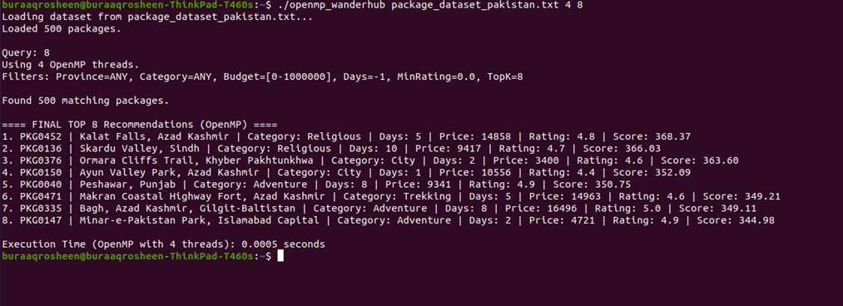

1. **is_only_number()**

**What it does:** Checks if input is only digits like 3.

### In simple words:

* + 3 → true
  + TOPK=3 → false

👉 **Used for:** treating 3 as TOPK=3.

1. **reset_query_defaults()**

**What it does:** resets filters to defaults.

### In simple words:

* + clears province/category
  + sets big budget range
  + sets TOPK=5
  + removes day/rating filter

👉 **Used for:** making new query clean.

1. **parse_line()**

**What it does:** reads one dataset row into arrays.

### In simple words:

* + skips header
  + splits by tab \t
  + stores id/place/province/category/price/rating etc.

👉 **Used for:** loading dataset in memory.

1. **parse_query()**

**What it does:** reads query and sets filters.

### In simple words:

* + resets defaults first
  + if only number → set TOPK
  + else split by ; and read PROVINCE/CATEGORY/BUDGET/DAYS/MIN_RATING/TOPK

👉 **Used for:** understanding user input.

1. **matches_filter()**

**What it does:** checks if package matches filters.

### In simple words:

* + province match (if given)
  + category match (if given)
  + budget range match
  + days match (if given)
  + rating >= min rating

👉 **Returns:** 1 match, 0 reject.

1. **calculate_score()**

**What it does:** calculates score for ranking.

### In simple words:

* + rating increases score
  + popularity increases score
  + more reviews increases score
  + budget closeness adds extra score
  + duration closeness adds extra score

👉 **Used for:** ranking top packages.

1. **sort_topk()**

**What it does:** sorts scores high to low.

### In simple words:

* + bubble sort
  + best score comes first

👉 **Used for:** showing best results on top.

1. **main() (OpenMP part)**

**What it does:** runs whole OpenMP program.

### In simple words:

1. loads dataset
2. reads and parses query
3. sets number of threads
4. **parallel loop** filters + scores packages
5. stores matching results
6. sorts and prints TOPK
7. prints execution time

👉 **Used for:** shared-memory parallel execution on one machine.

# MPI Implementation (Distributed-Memory Message Passing)

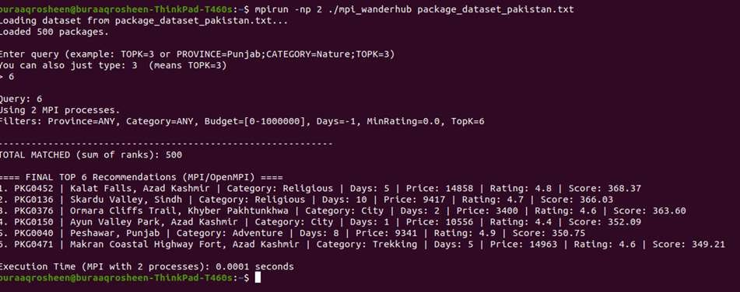

**is_only_number()**

### What it does:

Checks if the user input is only digits.

### In simple words:

* If input is 3 → it returns true
* If input is TOPK=3 → it returns false

👉 **Used for:** Allowing user to type only a number to set TOPK.

**reset_query_defaults()**

### What it does:

Resets all query filters to default values.

### In simple words:

* Clears province and category filters
* Sets budget range wide (0 to 1000000)
* Removes days filter
* Sets minimum rating to 0
* Sets TOPK to 5

👉 **Used for:** Making sure every new query starts clean.

**parse_line()**

### What it does:

Reads one row from the dataset file and stores it in arrays.

### In simple words:

* Skips header line (package_id)
* Splits line using tab \t
* Saves values into arrays like:
  + package id
  + place name
  + province



* + category
  + days, price, rating, reviews, popularity

👉 **Used for:** Loading the dataset into memory (only rank 0 reads file).

**parse_query()**

### What it does:

Reads the query string and sets filtering variables.

### In simple words:

* First resets defaults
* If query is just a number like 3 → sets query_topk = 3
* Otherwise splits query by ;
* Reads each filter like:
  + PROVINCE=...
  + CATEGORY=...
  + BUDGET_MIN=...
  + BUDGET_MAX=...
  + DAYS=...
  + MIN_RATING=...
  + TOPK=...

👉 **Used for:** Understanding what user wants in search.

**matches_filter()**

### What it does:

Checks if a package matches the user query filters.

### In simple words:

* If province filter exists → must match
* If category filter exists → must match
* Price must be in budget range
* If days filter exists → duration must match
* Rating must be >= min rating

👉 **Returns:**

* 1 → package is allowed
* 0 → package is rejected

**calculate_score()**

### What it does:

Calculates a score to rank packages.

### In simple words:

* Higher rating → higher score
* Higher popularity → higher score
* More reviews → higher score using log(reviews+1)
* If user set budget max → adds bonus for price close to budget
* If user set days → adds bonus for duration close to days

👉 **Used for:** Ranking packages from best to worst.

**sort_topk()**

### What it does:

Sorts packages by score (highest first).

### In simple words:

* Uses bubble sort
* Swaps items if score is smaller



* After sorting, best score is at index 0

👉 **Used for:** Getting top recommendations.

**bcast_dataset()**

### What it does:

Sends dataset from **rank 0 (master)** to all ranks using MPI broadcast.

### In simple words:

* Rank 0 loads dataset from file
* Then it broadcasts:
  + total number of packages
  + all arrays (ids, names, provinces, categories, prices, ratings, etc.)
    - Every rank gets the same dataset in its own memory

👉 **Used for:** Making sure all MPI processes have the dataset.

**main()**

### What it does:

Controls the full MPI program from start to end.

1. Starts MPI (MPI_Init)
2. Gets rank id and number of processes (rank, world)
3. Rank 0 reads dataset file
4. Dataset is broadcast to all ranks (bcast_dataset)
5. Rank 0 reads query, broadcasts query to all ranks (MPI_Bcast)
6. Each rank processes only its part of dataset:
   * computes its start/end range
   * applies filters + computes scores
   * sorts local results and keeps local TOPK
7. MPI collects results on rank 0:
   * MPI_Gather gets match counts
   * MPI_Gather gets topk counts
   * MPI_Gatherv collects indices + scores
8. Rank 0 merges, sorts again, prints final TOPK
9. Prints total execution time using MPI_Wtime()
10. Ends MPI (MPI_Finalize)

👉 **Used for:** Running the recommender in distributed parallel way using MPI.

## Comparison of Execution Models

|  |  |  |  |  |
| --- | --- | --- | --- | --- |
| **Feature** | **Serial** | **Pthreads** | **OpenMPI (MPI)** | **Client–Server (UDP)** |
| **Execution Type** | Sequential | Parallel | Parallel | Distributed |
| **Processing Style** | Single thread | Multiple threads | Multiple processes | Client sends, server  processes |
| **Memory Model** | Single  memory | Shared memory | Distributed memory | Separate memory  (network) |
| **Runs On** | Single CPU | Single machine | Multiple machines or  cores | Multiple machines |
| **Communication** | None | Shared variables | Message passing | Network messages |
| **Speed** | Slowest | Faster | Very fast (scalable) | Depends on network |
| **Complexity** | Very simple | Medium | High | Medium |
| **Synchronization** | Not required | Mutex/locks | MPI messages | Network protocol |
| **Scalability** | Very poor | Limited | Excellent | Good |
| **Fault Tolerance** | None | Low | Medium | High |
| **Best Use Case** | Small data | Multi-core  systems | Clusters / HPC | Remote querying |

## Advantages Table

|  |  |
| --- | --- |
| **Model** | **Advantages** |
| **Serial** | * Very easy to write and debug• No synchronization issues• Best for learning and small   datasets |
| **Pthreads** | * Faster than serial• Uses all CPU cores• No network overhead• Efficient shared memory   access |
| **OpenMPI**  **(MPI)** | * Highly scalable• Can run on multiple machines• Best for large datasets• Industry standard   for HPC |
| **Client–Server** | * Remote access supported• Multiple clients supported• Server always running• Platform   independent |

## Disadvantages Table

|  |  |
| --- | --- |
| **Model** | **Disadvantages** |
| **Serial** | * Very slow for large datasets• Wastes multi-core CPUs |
| **Pthreads** | * Shared memory issues• Race conditions possible• Harder to debug |
| **OpenMPI (MPI)** | * Complex code• Requires MPI setup• Message passing overhead |
| **Client–Server** | * Network delay• UDP is unreliable• Server can be bottleneck |

## When to Use Which?

### Situation Best Choice Learning / Testing Serial

**Multi-core PC** Pthreads **Cluster / Supercomputer** OpenMPI **Remote Query System** Client–Server

## Time Comparison Table

|  |  |  |  |
| --- | --- | --- | --- |
| **Model** | **Observed Execution**  **Time** | **Relative Speed** | **Explanation (Based on Results)** |
| **Serial (Sequential)** | **Highest (Slowest)** | ⭐ | Uses **single CPU core**. All filtering, scoring, and sorting are done **one-by-one**, so total time increases linearly with dataset  size. |
| **Pthreads (3 Threads)** | **Low** | ⭐⭐⭐ | Dataset is split among **multiple threads**. Filtering and scoring run **in parallel**, reducing execution time compared to serial.  Some overhead due to thread creation and mutex locks. |
| **OpenMP** | **Lower than Pthreads** | ⭐⭐⭐⭐ | Uses compiler-level parallelism with **less overhead**. Automatic work-sharing results in better CPU utilization than  manual thread management. |
| **MPI**  **(OpenMPI)** | **Very Low (Fastest)** | ⭐⭐⭐⭐⭐ | Work is divided among **multiple processes**. Each process computes independently, then results are merged. Scales best  for large datasets and clusters. |
| **Client–Server (UDP)** | **Medium** | ⭐⭐ | Server computation is fast, but **network communication**  **(send/receive)** adds delay, increasing total response time compared to pure local execution. |